New XXIO Prime Driver

Product Name: New XXIO Prime Driver

Product Intro Date: 16th November 2016

Product At Retail Date: 14.12.2016

Product Head-liner: Longer, Higher, Stunning Prime

Product Introduction:
To help you reach a new level of distance performance, xxio introduces the new xxio prime series. featuring advanced lightweight construction for faster head speed, a new head design for faster ball speed and powerful draw-biased performance, xxio prime is easy to hit with rewarding results

Features & Benefits

This latest model has been specifically designed for the golf swings of XXIO Prime users, providing further distance and more powerful trajectory. Our main focus was on designing a longer shaft with less weight that creates faster head speed, greater playability and a powerful draw bias. The newly developed shaft is 46 inches and less than 40 grams, which is 0.25 inches longer and 2 grams lighter than the previous model. The new driver has been perfected for faster head speed and more square impact, resulting in straighter ball flight and 4.3 more yards of distance compared to the previous model.

In a comparison study of the main target market (golfers with the head speed of 37m/s or less), users were asked to test the XXIO Prime clubs and XXIO9 clubs. Results showed that XXIO Prime drivers provided 3.5 yards longer distance and are highly recommendable to golfers with gentler swings.

Stronger Trajectory with SRIXON Sports’ Original Technology
1. The new 46-inch shaft provides faster head speed, greater playability and a powerful draw bias
The unique layered structure and materials utilized for this newly developed XXIO Prime SP-900 series allow the carbon shaft to be extended to a full length of 46-inches and help reduce the total weight of the club by 4 grams (2 g reduction of shaft, 2 g reduction of grip). These new technologies have realized a faster head speed and easier control, presenting an advanced driver that provides a powerful draw bias for straighter and longer drives.

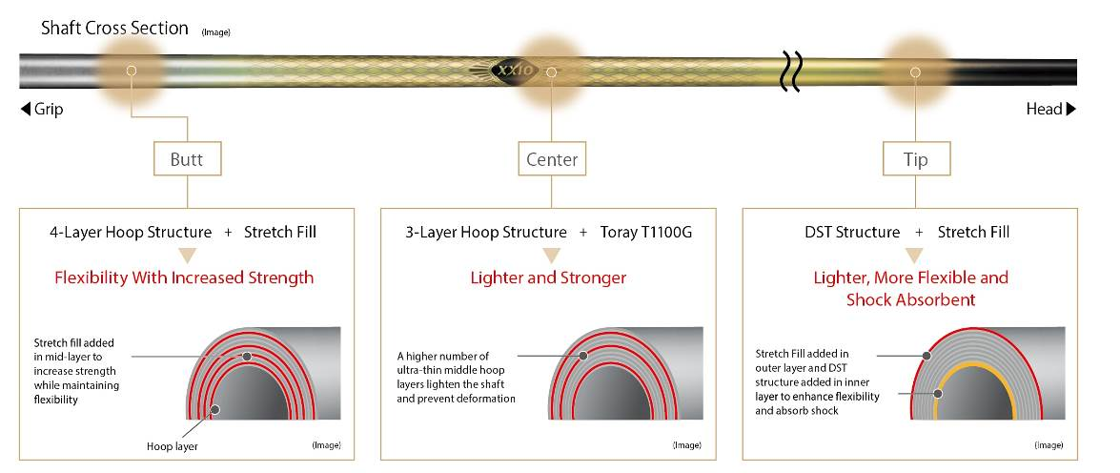

2. Provides outside-in club head path with more square impact
Stretch-fill is an advanced material that gives the tip section of the shaft both flexibility and strength and creates a powerful draw bias. By contouring the toe and back, and expanding size and body thickness of heel area, the shape of the club head provides a draw biased image to XXIO Prime users who have a strong tendency to swing outside-in and helps them hit the ball more square at the impact. It reduces slice spin at the impact and loss of distance, and promotes straighter and greater trajectory.

Swing characteristic of Prime users SP-900 Carbon shaft E I Curve data
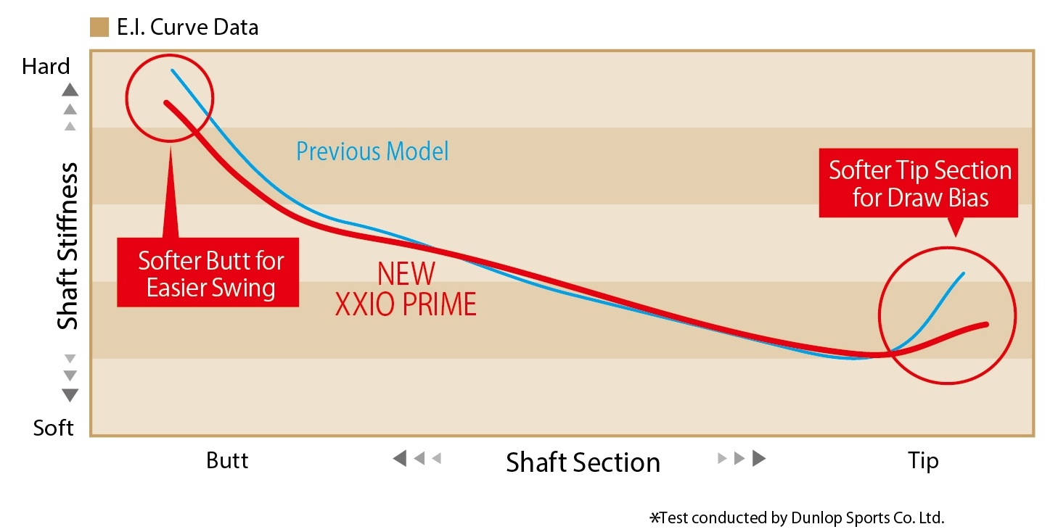
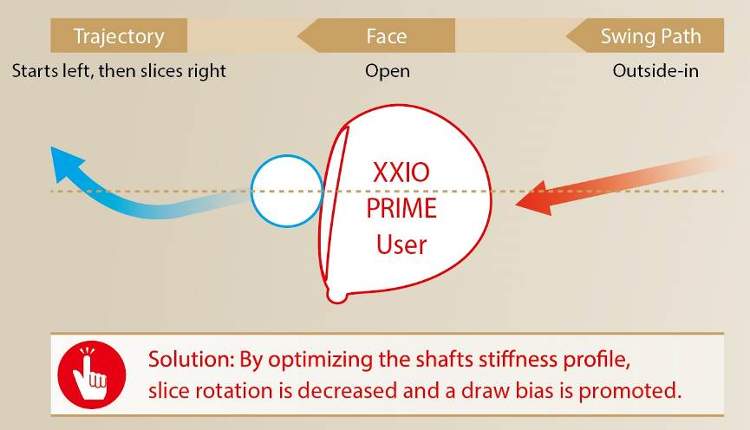

3. Newly developed club head with improved face repulsion performance
The Wing Cup Face, which was developed for the XXIO 9 series and expanded toe and heel angles, and the newly developed sole groove structure have improved the repulsion performance at the toe and heel of the face. The new club head provides greater forgiveness.
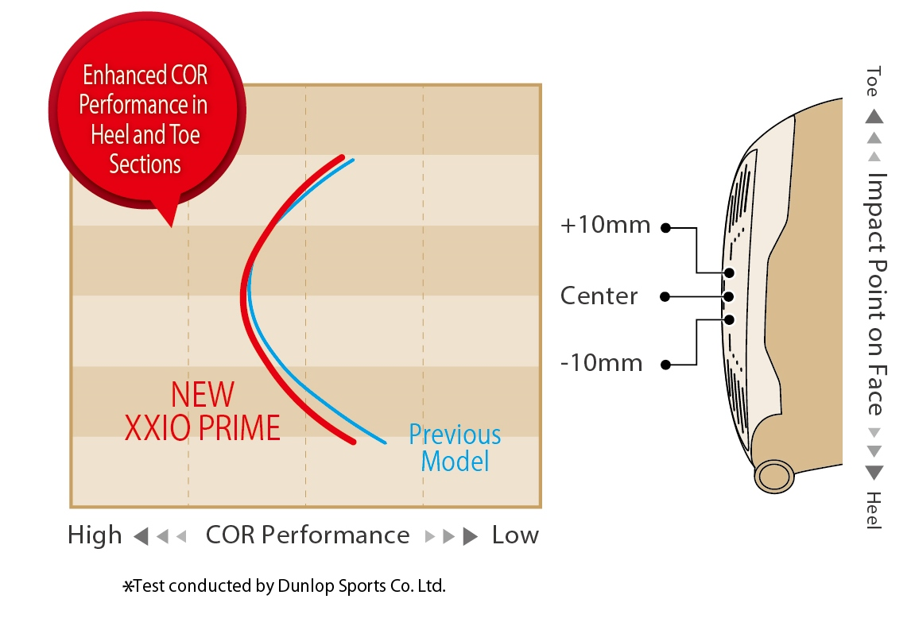
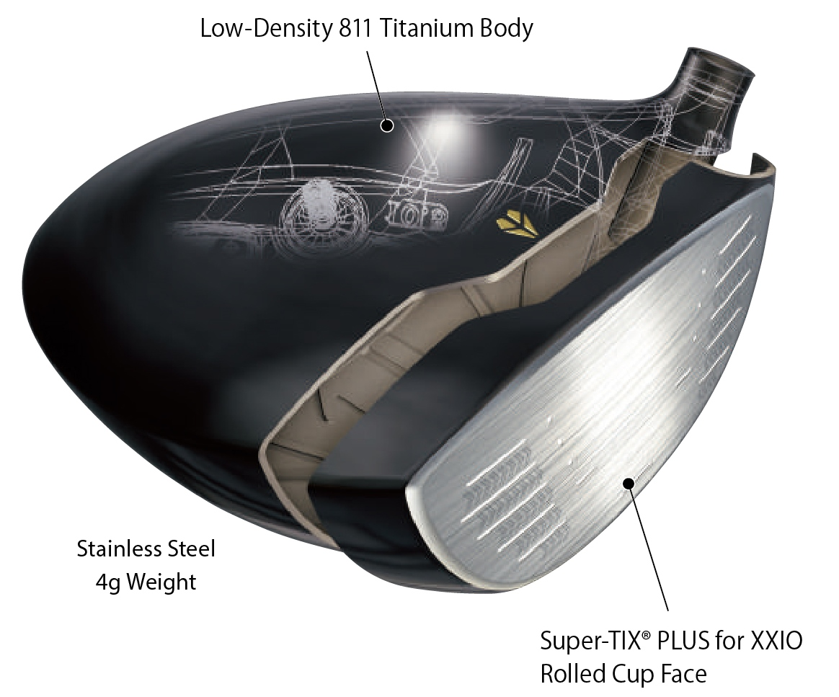

4. A lower and deeper CG for better launch and accuracy
The Lightweight Crown with a weight reduction design enables optimal distribution of excessive weight across the head and heel. It facilitates a lower and deeper CG, and a higher MOI. In combination with the shallow back shape succeeded from the previous model, it promotes better launch and accuracy.

Accenting the traditional gold coloring of the XXIO Prime series with a platinum color scheme gives the new series a sense of additional matureness and luxuriousness. The addtion of royal dark purple to the head provides a finished elegance that compliments the platinum gold sole to give the entire XXIO Prime series a renewed image.
The three-toned shaft has silver coloring at the top, gold in the middle and black at the bottom end. The tonal coloring expresses the flexibility of the top and bottom ends, and the head has been color coordinated to match.

Specifications
Head material
Face: Titanium (Super-TIX® PLUS for XXIO)
Body: 8-2 titanium + SUS weight
Construction
Face: Forged
Body: Vacuum precision casting
Finish
Gold ion plating + high-gloss metallic coating; mirror + satin + bead-shot finish;
Badge: Gold
Grip
XXIO Prime original full rubber grip (with logo)

Shaft
Model | Flex | Kickpoint | Weight (g) | Torque
XXIO Prime SP-900  Carbon shaft | SR | middle | 38 | 6.7
 | R | middle | 36 | 6.8
 | R2 | middle | 36 | 6.9
*Weight with club head attached
Standard model specifications
Model | #1
Loft Angle (°) | 10.5 | 11.5
Lie Angle (°) | 58.0
Head Volume (cm³) | 460
Club Length (in) | 46.0
Swing Weight | D3
Club Weight (g) R | 252
Line-up by standard model
Loft Angle | 10.5 | 11.5
SR | ○
R | ○ | ○
R2 |  | ○
○ indicate stock line-ups. All others are custom order.

SRP:
Euro: 999,99
CHF: 1099,99
SEK: 9349,00

