CLEVELAND GOLF INTRODUCES LAUNCHER HB TURBO IRONS, LAUNCHER UHX IRONS AND LAUNCHER HALO

SAINT JEAN DE LUZ, France – Sept. 16, 2019 – Cleveland® Golf is proud to announce the release of the Launcher HB Turbo Irons, Launcher UHX Irons and Launcher Halo. Built for more speed and more precision, step up and launch it with the latest generation of irons and hybrids from Cleveland Golf. Cleveland’s Launcher HB Turbo Irons, Launcher UHX Irons and Launcher Halo officially launch in Continental Europe on October 15, 2019.

Launcher HB Turbo Irons

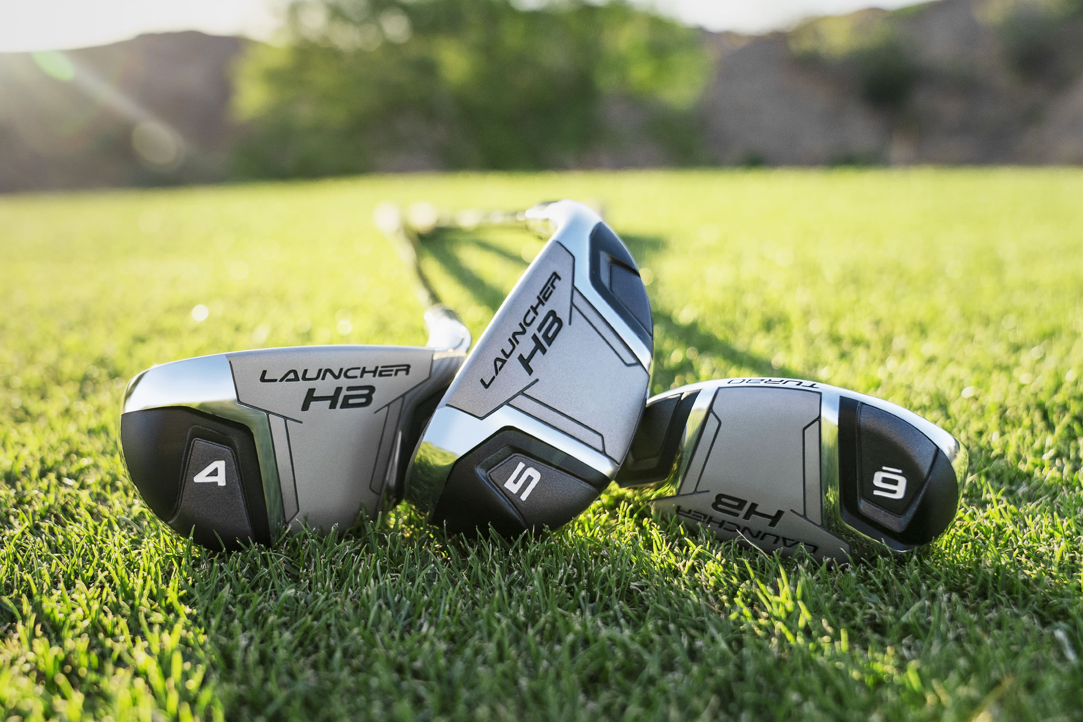The Launcher HB Turbo Irons deliver maximum forgiveness and an easy-to-hit to profile specifically targeted at game improvement players seeking more distance and more accuracy.

“These irons allow game improvement players the ability to get the ball into the air better than any iron on the market,” said Lionel Caron, President Continental Europe. “Now with a thinner, hotter face, the Launcher HB Turbo Irons give you a half club more distance over the previous generation.”

Launcher HB Turbo Irons maintain a fully hollow construction, allowing for optimized sole weighting for shots that launch higher, but now incorporate a new high strength, turbocharged face insert that is thinner and hotter for more speed on every shot.

The redesign HiBore Crown pushes the center of gravity low and deep within the base of the Launcher HB Turbo Irons. This placement produces shots that launch off the face, fly high, and stay on their intended target. Progressive shaping throughout the entire set maintains forgiveness in the long irons, with compact short irons that provide optimal control.

Key Innovations Inside the Launcher HB Turbo Irons:

- 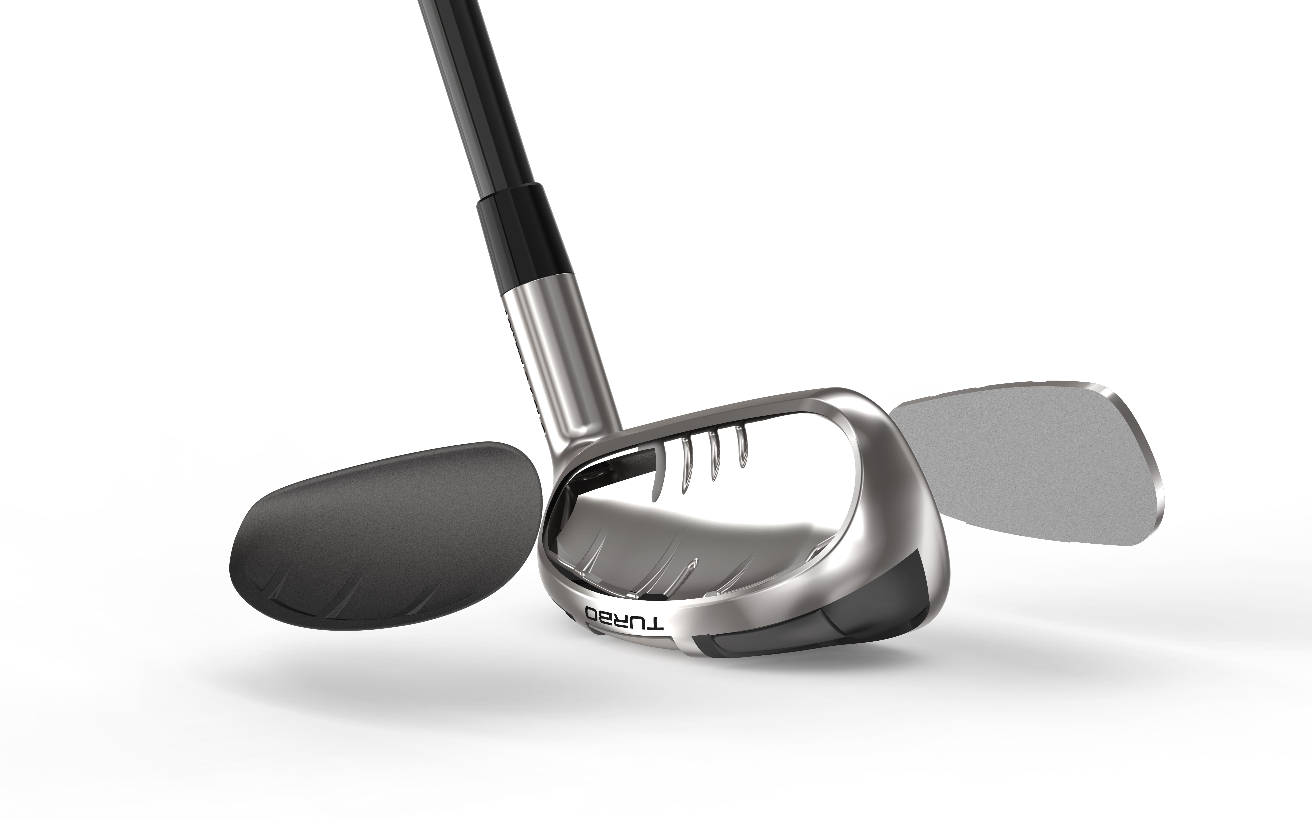Hollow Construction: Fully hollow construction along with internal stabilizing ribs provides ultimate forgiveness on every shot.
- Turbocharged Face: Each iron features a turbocharged, high strength steel face that is thinner and hotter for increased ball speeds and explosive distance.
- HiBore Crown: Redesigned HiBore Crown features low, deep weighting to produce an easy to hit, high ball flight.
- Progressive Hollow Shaping: Progressive shaping provides a smooth transition from hybrid-like long irons to iron-like short irons. It’s a seamless changeover with forgiveness where you need it and control where you want it.

Cleveland’s Launcher HB Turbo Irons are available in both men’s and women’s along with right and left hand options. The Launcher HB Turbo Irons are priced at 599 € / 659 CHF / 5990 SEK MAP for a five-piece steel set. For graphite options, the Launcher HB Turbo Irons are 699 € / 769 CHF/ 6990 SEK MAP for a five-piece set.

For high-resolution images, the Launcher HB Turbo Irons product manual, and other assets click on the link below :
Turbo Launcher HB

For more detailed information on the Cleveland Launcher HB Turbo Irons, please visit: clevelandgolf.eu

ABOUT Cleveland® Golf:
Based in Huntington Beach, CA, Cleveland® Golf is part of the Sumitomo Rubber Industries, Ltd. family and enjoys a strong presence on competitive tours worldwide. Their professional staffs include players such as Graeme McDowell, Keegan Bradley, Hideki Matsuyama, Shane Lowry,, Inbee Park, as well as many others. Cleveland® Golf, founded in 1979, is a leading equipment manufacturer specializing in short game technologies and solutions that benefit all golfers. Cleveland® Golf remains steadfastly committed to providing "Tour proven, premium golf equipment to passionate golfers seeking to improve their performance while enhancing their experience playing the game of golf." For more information, please visit us online at https://www.clevelandgolf.eu

Launcher UHX Irons

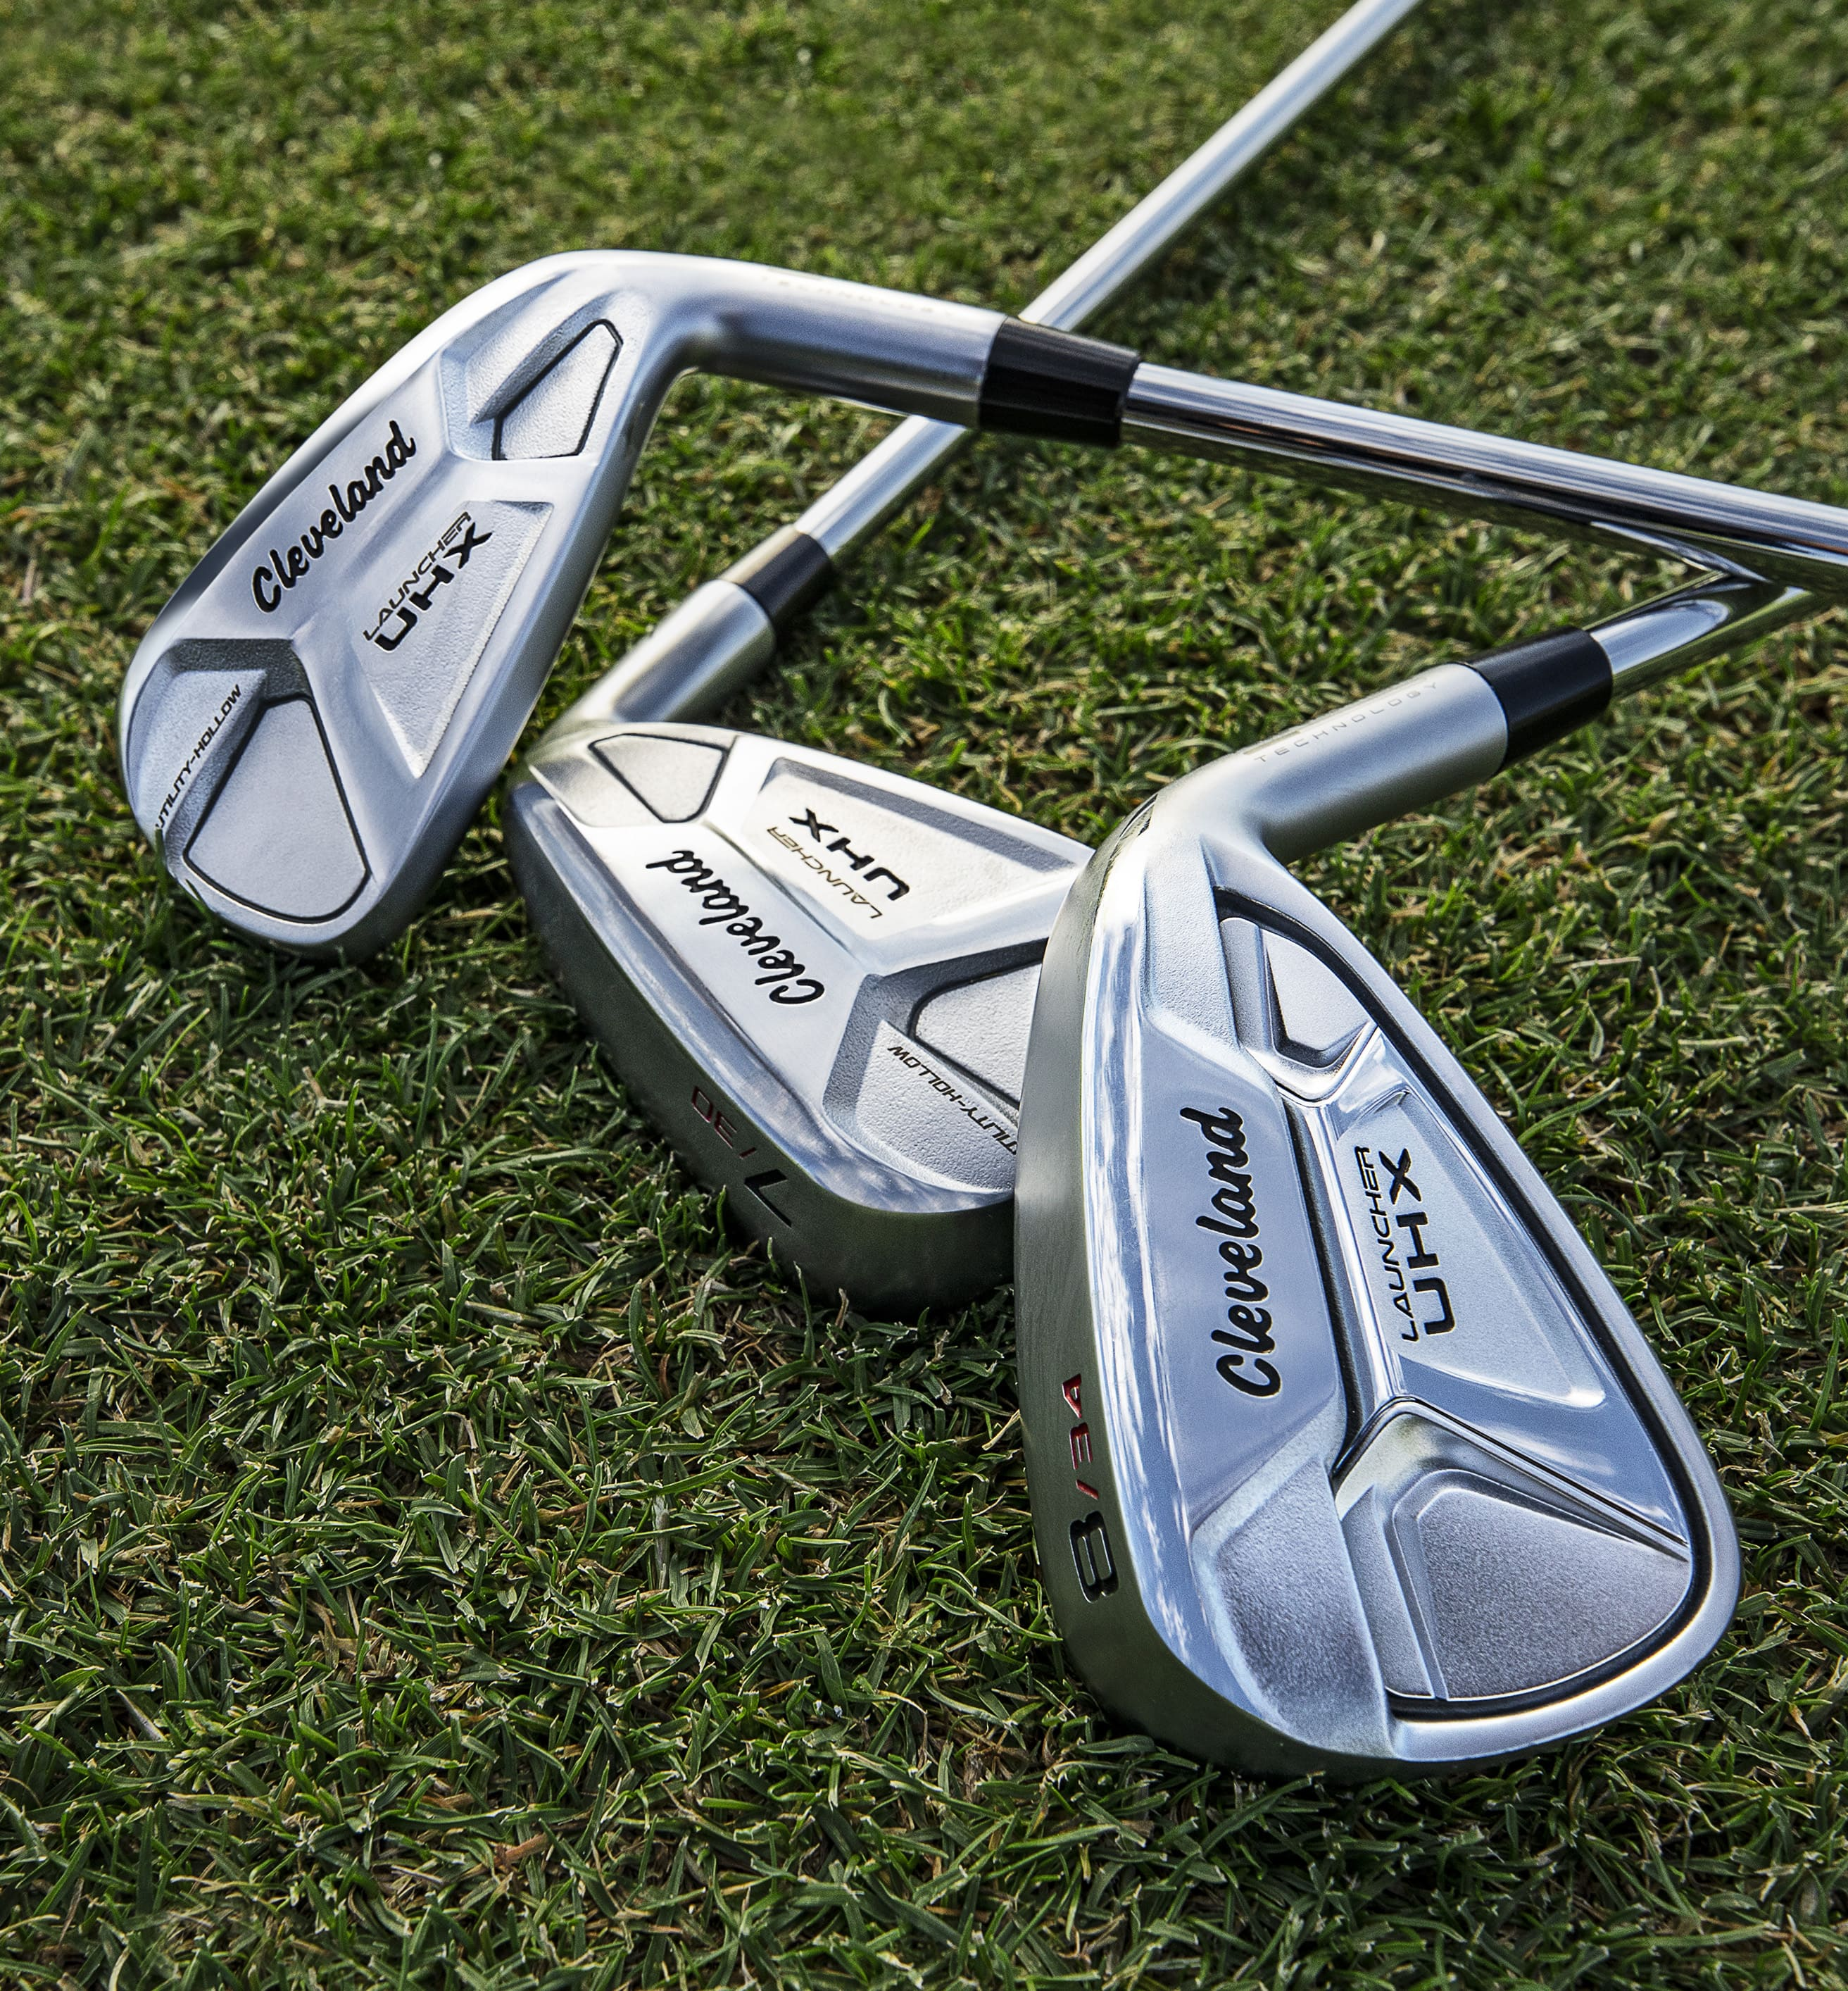The Launcher UHX Irons are the most progressive combo set of hollow and cavity back irons on the market. It’s a completely new way to approach one complete set of irons.

“This combination of cavity back and utility irons into one set offers the perfect blend of distance and accuracy,” Brekke said. “A new variable face pattern delivers more distance due to hotter faces with better mass distribution.”

Launcher UHX Irons incorporate hollow long irons (4-7-irons) for more distance and forgiveness, with lower and deeper weighting compared to traditional cavity back irons. Meanwhile, the 8-iron through pitching wedge features a cavity back construction, which focuses on precision and control rather than maximizing distance. The result: a seamless transition throughout to create one unified iron set.

Furthermore, Launcher UHX Irons feature a high strength, variable steel face insert, incorporated into each long iron, for higher ball speeds across the entire face and more distance on every shot. The latest iteration of our V-Shaped Sole offers added forgiveness and improved speed retention, while Cleveland’s proprietary Tour Zip Grooves and enhanced Laser Milling delivers reliable, consistent spin when attacking the pin.

Launcher UHX Utility Irons will also be available as individual clubs for sale to add forgiveness to any iron set. Offered in 3, 4, and 5-iron lofts, Launcher UHX Utility Irons deliver the distance and forgiveness of a hybrid in an iron-like address profile.

Key Innovations Inside the Launcher UHX Irons:

- Hollow and Cavity Back Construction: Hollow long irons provide more forgiveness, while cavity back short irons provide more control when attacking the pin.
- Variable High Strength Steel Face: A variable high strength HT1770M steel face insert delivers explosive ball speeds for increased distance, even on heel and toe impacts.
- V-Shaped Sole: Featured in both the cavity back and hollow designs, the V-Shaped Sole improves turf interaction for better speed retention at impact.
- Tour Zip Grooves: Tour Zip Grooves and Laser Milling deliver maximum spin for optimal control throughout the Launcher UHX Irons.

Cleveland’s Launcher UHX Irons are available in both men’s and women’s offerings along with right and left hand options. The Launcher UHX Irons are priced at 599 € / 659 CHF / 5990 SEK MAP for a five-piece steel set. For graphite options, the Launcher UHX Irons are 699 € / 769 CHF / 6990 SEK MAP for a five-piece set.
The Launcher UHX Utility Irons are priced at 179 € / 199 CHF / 1790 SEK MAP.

For high-resolution images, the Launcher UHX Irons product manual, and other assets, click on the link below :
UHX irons

For more detailed information on the Cleveland Launcher UHX Irons, please visit clevelandgolf.eu

ABOUT Cleveland® Golf:
Based in Huntington Beach, CA, Cleveland® Golf is part of the Sumitomo Rubber Industries, Ltd. family and enjoys a strong presence on competitive tours worldwide. Their professional staffs include players such as Graeme McDowell, Keegan Bradley, Hideki Matsuyama, Shane Lowry,, Inbee Park, as well as many others. Cleveland® Golf, founded in 1979, is a leading equipment manufacturer specializing in short game technologies and solutions that benefit all golfers. Cleveland® Golf remains steadfastly committed to providing "Tour proven, premium golf equipment to passionate golfers seeking to improve their performance while enhancing their experience playing the game of golf." For more information, please visit us online at https://www.clevelandgolf.eu

Launcher Halo
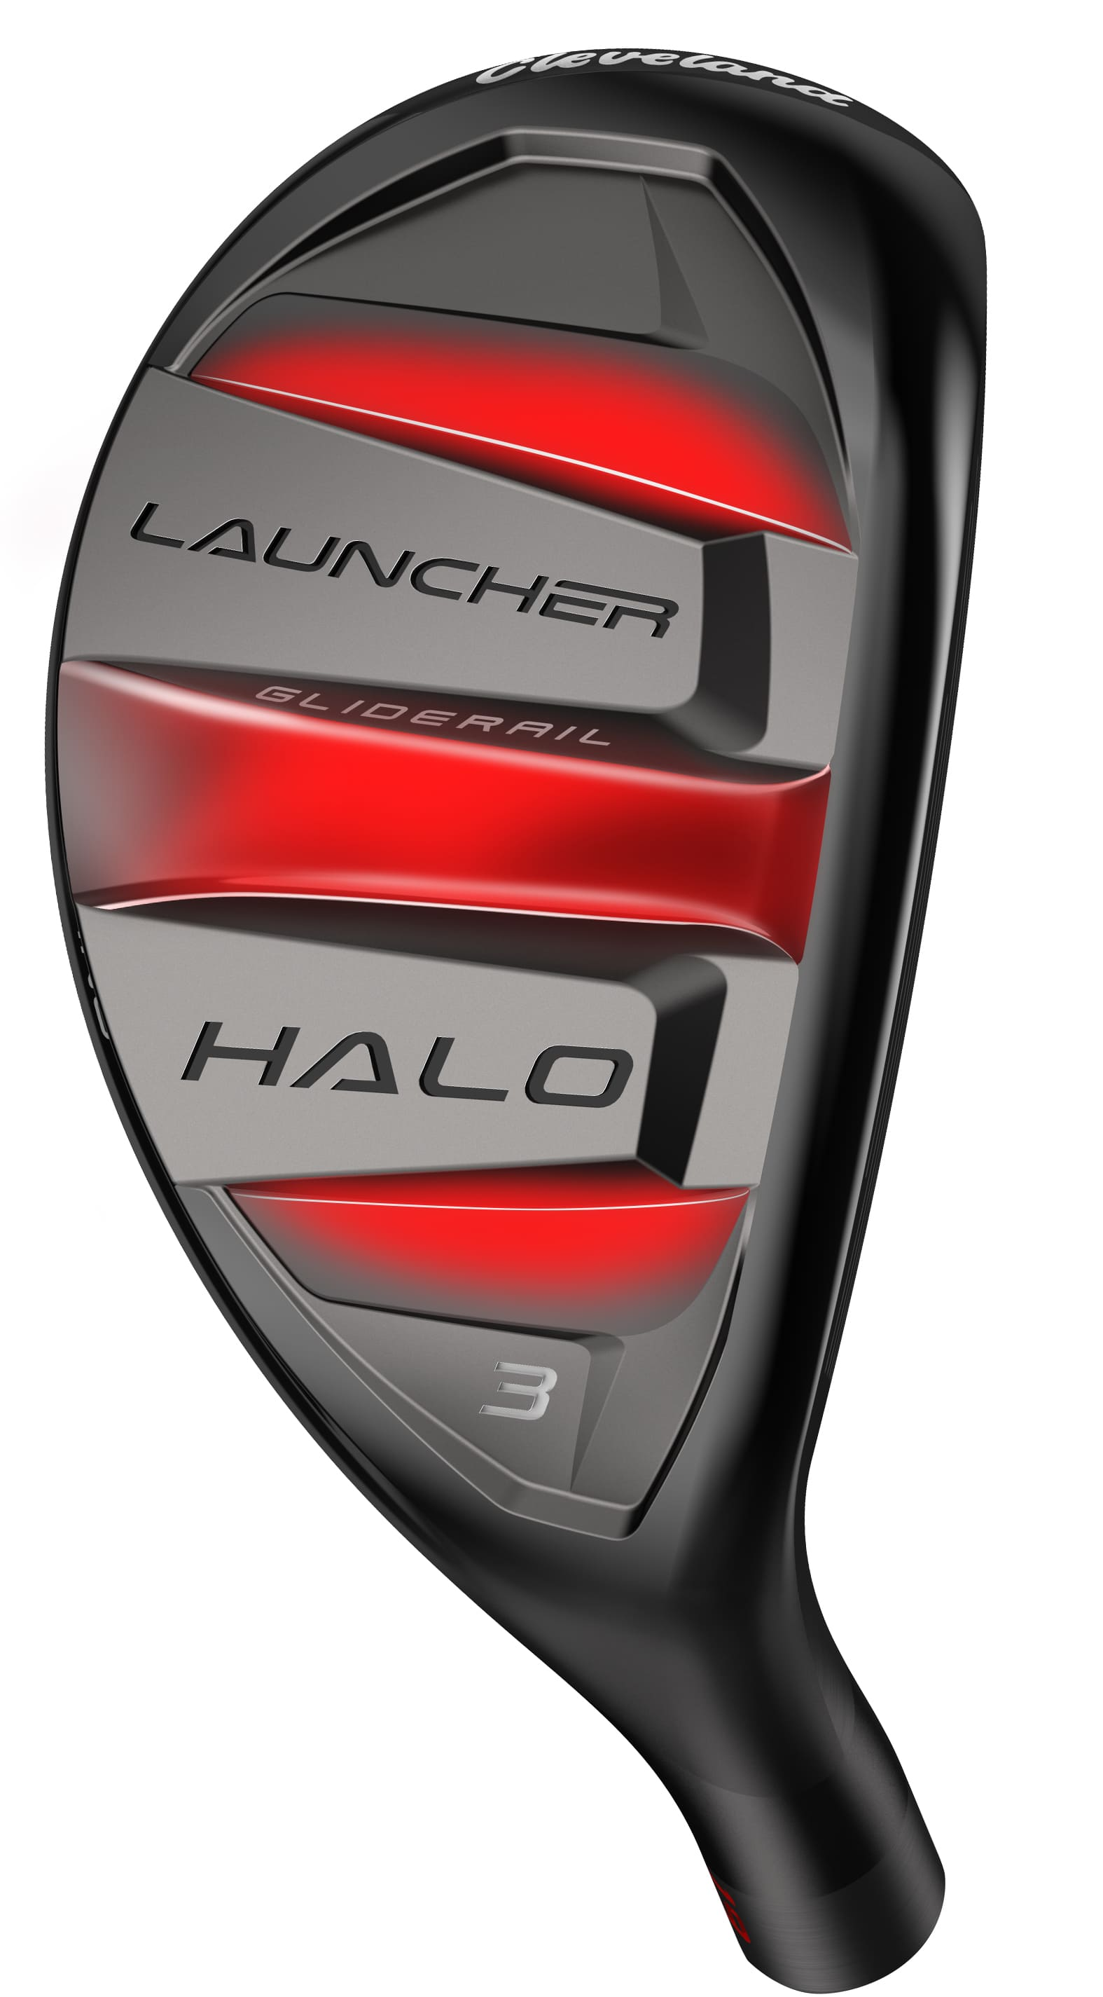
The Launcher Halo returns, offering a versatile scoring club designed for any situation. Featuring new Gliderail Technology, the Launcher Halo is optimized for better turf interaction from the toughest of lies.

“We all hit it in the rough and find ourselves in difficult positions out on the course,” said Lionel Caron, President Continental Europe. “And it’s those tough places that add big numbers to our scorecards. The new Launcher Halo helps us not only get out of those tough spots, but helps us excel from them and get into scoring position. It’s so much more than a typical hybrid.”

While the Gliderails provide optimal speed retention, the enhanced HiBore Crown pushes the center of gravity low and deep for a low spin, high launch ball flight. Halo Weighting shifts more weight to the perimeter for increased MOI and better overall forgiveness.

A new variable face insert, utilizing HT1770M steel, allows the Launcher Halo to provide improved ball speeds for more distance, even on off-center strikes.

Key Innovations Inside the Launcher Halo:

- Gliderails: Featuring a set of three rails, the leading edge and sole geometries are optimized for improved turf interaction and speed retention.
- HiBore Crown: The redesigned HiBore Crown enables a lower CG position, promoting that ideal low spin, high launch ball flight.
- High Strength Steel Face: Constructed using high strength steel, the variable face insert provides higher COR over a larger impact area leading to increased ball speeds and distance.

Cleveland’s Launcher Halo is available in both men’s and women’s offerings along with right and left hand options. The Launcher Halo is priced at 199 € / 219 CHF / 1990 SEK MAP and offered in 2 (16°), 3 (19°) and 4 (22°) Halo models.

For high-resolution images, the Launcher Halo product manual, and other assets, click on the link below :
Launcher Halo Hybrid

For more detailed information on the Cleveland Launcher Halo, please visit: clevelandgolf.eu

ABOUT Cleveland® Golf:
Based in Huntington Beach, CA, Cleveland® Golf is part of the Sumitomo Rubber Industries, Ltd. family and enjoys a strong presence on competitive tours worldwide. Their professional staffs include players such as Graeme McDowell, Keegan Bradley, Hideki Matsuyama, Shane Lowry,, Inbee Park, as well as many others. Cleveland® Golf, founded in 1979, is a leading equipment manufacturer specializing in short game technologies and solutions that benefit all golfers. Cleveland® Golf remains steadfastly committed to providing "Tour proven, premium golf equipment to passionate golfers seeking to improve their performance while enhancing their experience playing the game of golf." For more information, please visit us online at https://www.clevelandgolf.eu

